Readings & Assignments: Week 5

Week 5 Readings
Complete the following readings early in the week:
- Week 5 online lectures
- From 3ds Max Help file, read the following topics:
  - Render Frame Window
  - RAM Players
  - Make Preview or View Preview
  - Render Settings
While reading, make note of pertinent and important facts. You will be required to reference your readings in discussions and apply them in this week’s assignments.
Week 5 Assignments Overview
Assignment Summary: Week 5 | Due Date
Assignment 1: Discussion Questions | Saturday, March 20, 2010
Assignment 2: Final Project | Monday, March 22, 2010
Using the navigation on the left, please proceed to the next page.

Week 5 Overview
From Week 1 through Week 4, you learned about concepts related to UVW mapping and animation of three-dimensional (3D) objects. These two distinct areas are equally important for creating a 3D animation.
This week, you will review some of the important topics covered in this course. You will review concepts of UVW mapping coordinates, unwrapping UVWs, animation and keyframing, linking, constraints and controllers, and movement and timing.
Let’s begin this week by revising the UVW mapping concepts.

Learning Outcomes:
- Create complex material and UVW mapping solutions.
- Demonstrate the ability to apply basic material to 3D models.
- Exhibit the ability to apply animation techniques to 3D models.
- Show the ability to use advanced controllers in animating and linking models.
- Manipulate animation curves to refine movement and timing.
During Week 1 and Week 2, you were introduced to UVW mapping coordinates.You learned that when you create a model in 3D, it has a certain level of detail but lacks personality, regardless of whether it is an inanimate object or an action hero in a video game.

UVW Mapping Coordinates
The U, V, and W describe a mesh’s surface direction in which textures are placed. Without these coordinates, it is difficult to place unique markings on 3D objects. The key to successfully assign proper mapping coordinates is to take an object’s polygons, which can face in all different direction on the XYZ axis, into planar pieces. To achieve this, 3ds Max provides you different mapping gizmos to help generate mapping coordinates based on basic primitive shapes. This is similar to taking the label wrapped around a water bottle, peeling it off, and laying it flat on a table. It would be much easier to draw on the label if it were lying on a flat surface than if it were still wrapped around the bottle.

Unwrapping UVWs
Since all 3D objects are not primitive shapes, such as a box, a sphere, or a cylinder, 3ds Max provides an unwrapping tool—the Unwrap UVW modifier. This modifier is a one-stop shop for all the essential UVW tools and parameters. Using this modifier can ensure that you create proper mapping solution for your 3D objects. When you minimize seams and mapping clusters, you can create a simpler UVW template to paint the texture for your model. By using both the 3ds Max viewports and constantly updating the changes being made in the Edit UVW window, you will see the results in real time and be able to create the final layout of the mapping clusters within the mapping space.
Next, you will review the concepts related to 3D animation as discussed in
Week 3 and Week 4.
There are many different aspects that make up computer-generated graphics, but none are as popular as animation. Let’s revise the key concepts of animation that you learned in Week 3 and Week 4.

Animation and Keyframing
Animation is not possible in a 3D environment without establishing keys at specific moments in time. These keys save an object’s current state on a frame, and placing multiple keys throughout a time line generates motion.
Linking, Constraints, and Controllers
3ds Max offers many tools to help make the animation process easier. Without these tools, animation can be a time-consuming practice, where a number of keys need to be set manually. Constraints and controllers enable you establish relationships between different 3D objects and automate their motion. For example, if you want a fighter plane to do an aerial movement, you could do this by creating a path that defines the required motion and then constrain the fighter plane to move on a path designed for the desired move.
In addition, having multiple objects share a common bond can assist in animating complex meshes and groups of meshes together. A hierarchical chain of objects consists of a parent, an object, and children that are linked to their parents. When creating a link between objects, it is important to remember that always a child is linked to its appropriate parent and not vice versa. The top of the chain cannot have a parent and it is known as the root.
Movement and Timing
In order to create a desired motion for your scene, it is important to define the movement and timing of your animation. Using animation editors to view the keys and the function curve will give you more control on how those keys move in and out of each other on the time line. Having more control over a key’s value and possibly changing that key’s tangent type can drastically alter the look of an animation. The 3ds Max software interpolates between keys, but the shift from one key to another key needs to be adjusted manually to refine the look of the animation. Once the keys are established, fine-tuning the timing and motion is essential. Being able to not only look at the animation curves and tangent type but also move, scale, and edit individual keys or groups of keys in the Track View - Dope Sheet can help you fine-tune the timing of any animation. In the next section, you will do a visual recap of 3D modeling and animation with the help of a Gun Turret model.

3D Modeling and Animation
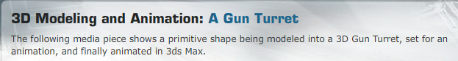
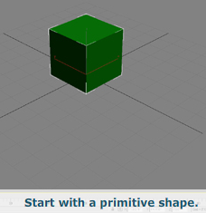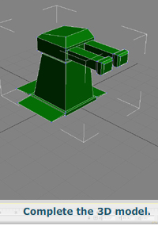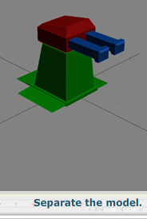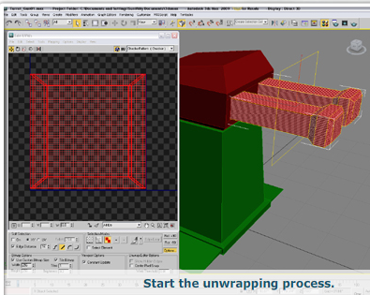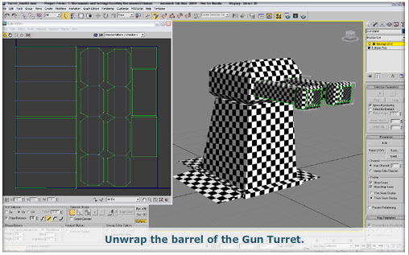
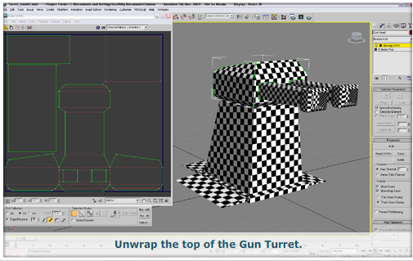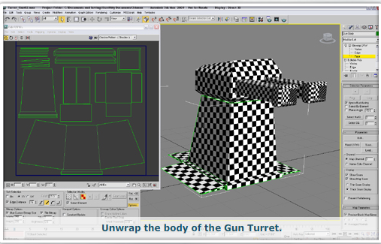
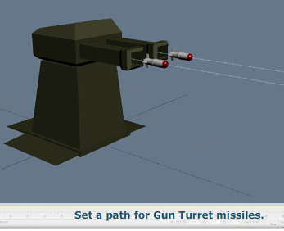
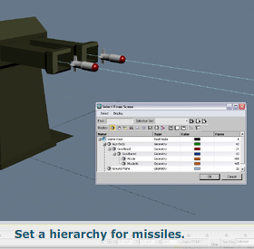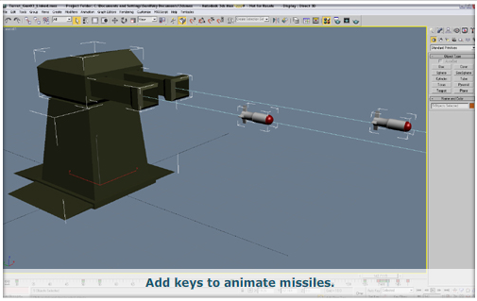
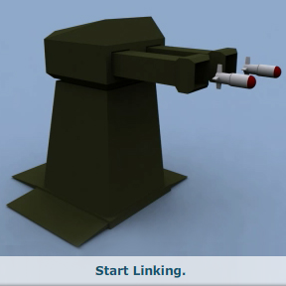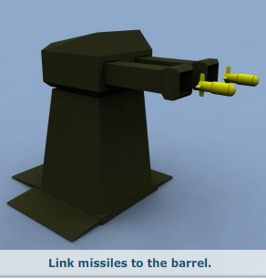
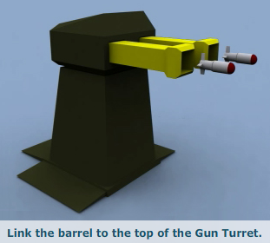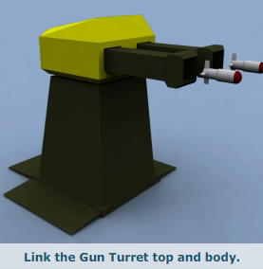
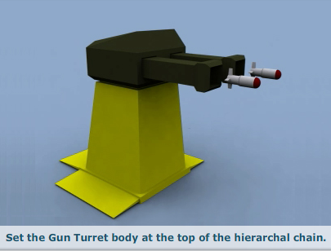

Summary
This week, you revised some of the key concepts that you learned in the last four weeks of the course. These concepts are important in adding aesthetics and motion to 3D models and scenes. When added to your knowledge of 3D modeling, these key concepts can enhance the look and quality of your work.
Next week, you will conclude the course by briefly reviewing what you covered in each week of the course and by completing the final project assignment.
Assignment 1: Discussion Questions
By Saturday, March 20, 2010, respond to the discussion questions assigned to you by the facilitator. Submit your responses to the appropriate Discussion Area. Start reviewing and responding to your peers’ posts as early in the week as possible. You can ask a question, post a comment, or add a point to expand the discussion. Be honest, clear, and concise.
Always use constructive language, even in criticism, to work toward the goal of positive progress. Make sure to use your course text or other research when possible in your responses.
Support your statements with appropriate references wherever necessary. Follow current MLA guidelines for writing style, spelling, grammar, and citation of sources.
Assignment 1 Grading Criteria | Maximum Points
Response Criteria:
Met the criteria for the correct responses to the questions assigned. | 4
Used vocabulary relevant to the current and previous weeks' topics—at least five terms. | 4
Participation Criteria:
Used vocabulary relevant to the current and previous weeks' topics—at least five terms. | 4
Participated in the discussion by asking a question, providing a statement of clarification, providing a point of view with a rationale, challenging a point of discussion, or making a relationship between two or more points of the discussion. | 4
Justified ideas and responses by using appropriate examples and references from textbooks, Web sites, and other references or personal experience. | 4
Total: | 20
For assistance with any problems you may have when completing this assignment—OR—to offer your assistance to classmates, please use theProblems and Solutions Discussion area located through the left side navigation link.
This week, completing the final project and wrapping up the class, just answer questions 2 and 3. As usual, post your work here and make sure to reply to AT LEAST 2 of your peers.

DQ 2: How can two different objects be animated together such that both are shown moving at the same time, with the same pace, and without any slippages or improper movement? Share at least two examples. Also, share an example from your final project scene where you would need to animate two objects together at the same time and pace.
DQ 3: What is the difference between hierarchical linking and a link constraint? Share an example of when you would use hierarchical linking and when you would use a link constraint.
DQ1: When animating an object traveling from one destination to another in a 3D environment, what techniques can be used to ensure accurate motion and direction? In the final project scene you are developing, where would you want to apply these techniques? Explain how it will help enhance your scene.
DQ4: Other than keyframing the different objects in the final project animation, what are other options to help make the objects look like they are traveling down the conveyor belt? Provide at least two such options and explain how they would help achieve the desired result in the final project animation.
Assignment 2: Final Project
This week, you’ll continue to animate both the vehicle and parts in the environment. Be sure to use constraints and other animation techniques to make the animation believable. Post the final animation for critique.
Perform the following:
- Finish all animation for both the vehicle and environment. Be sure to use some of the animation techniques you read about in the lecture and the textbook
- Add final touches and adjust the animation to refine and polish the motion.
- Use lighting and shadows to add interest and depth to the environment.
- Render the final animation from a perspective that showcases all of the objects in the scene and the animation of the vehicle and environment.
- Render the file at a resolution of 320 x 240 pixels. Save the final, production-quality render as a QuickTime movie. Name it as W5_A2_LastName_FirstName_Final.mov. Submit the file to this Discussion Area by Monday, March 22, 2010.
Note: You’ll revise the animations next week based on the feedback you receive from your peers and the facilitator this week.
Discussion
By the end of the week, use this Discussion Area to discuss the following:
- What different techniques did you use to create the final render?
- Did you use constraints and helpers in the animation? How did they assist in the animation?
Critique Exercise
By the end of the week, use this Discussion Area to review and comment on the assignment posted by at least two of your peers. Provide constructive feedback on what can be done to improve the overall look-and-feel of the animation.

Assignment 2 Grading Criteria | Maximum Points
Submitted a final animation that made good use of animation principles, exhibited proper timing, and met the requirements as listed in the final project requirements. | 50
Used proper lighting, shadows, and render quality in the animation. | 20
Discussed the techniques you used to create the final render and explained how the constraints and helpers assisted in the animation. | 10
Reviewed and critiqued the submissions of at least two peers on the basis of the critiquing and discussion guidelines. | 10
Total: | 90
For assistance with any problems you may have when completing this assignment—OR—to offer your assistance to classmates, please use theProblems and Solutions Discussion area located through the left side navigation link.
This week we are looking for the final project to be pretty much done. Week 6 only has a few days in it which only gives us time to only make a few tweaks based on the feedback from this week. In other words, don't leave any major implementations until the last couple of days or you will run out of time.
Post your work here and provide feedback to at least 2 of your peers.

